20
Northwest Women’s
Music (and Arts) Celebration
Together Again!!!!
Fall camp! October 6-8, 2023
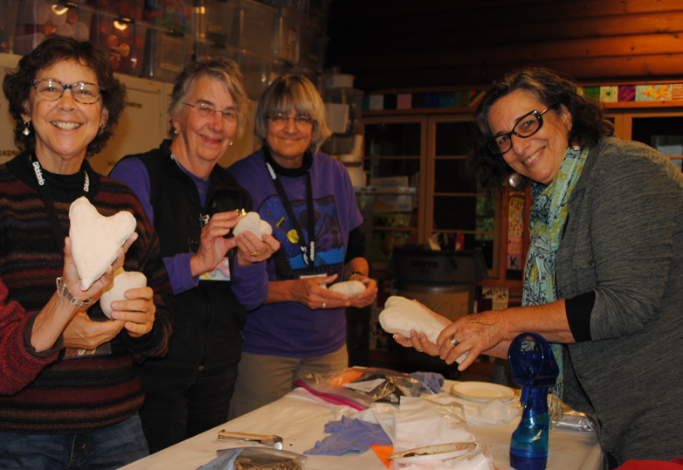
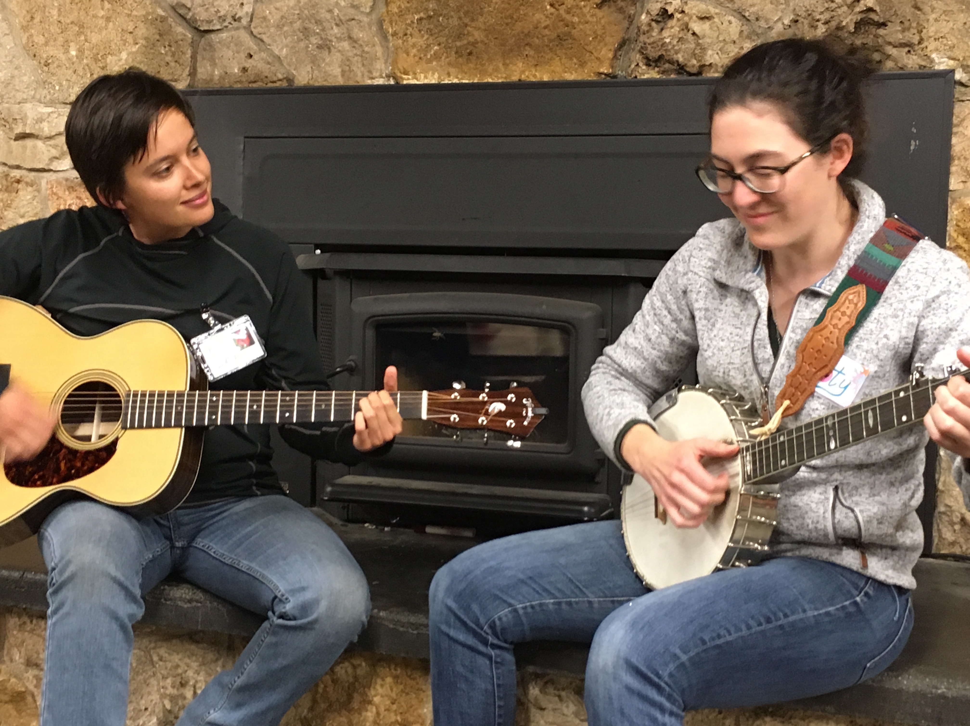
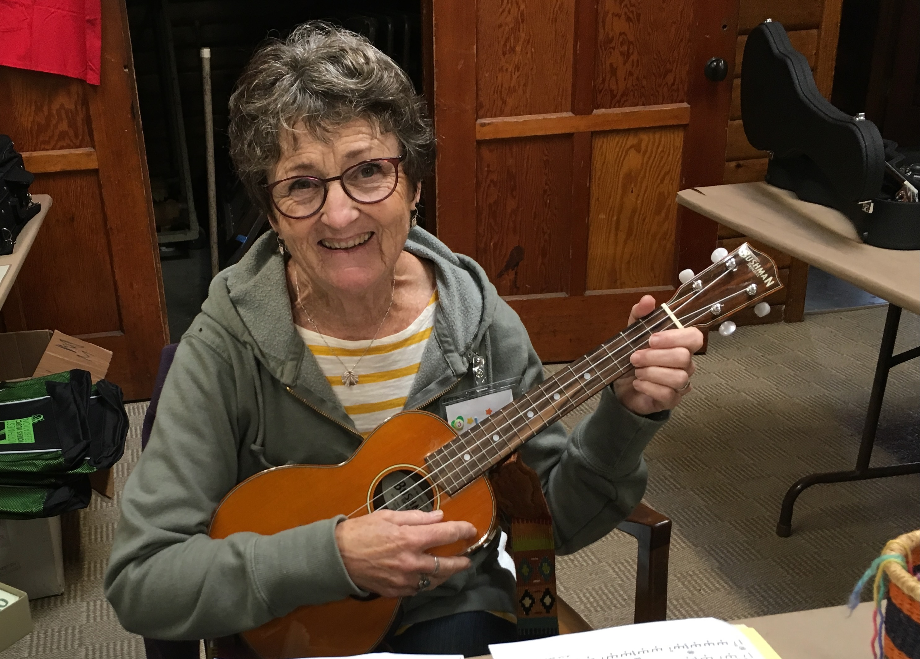

Pilgrim Firs Conference Center
Port Orchard, WA

Imagine your creative potential. Banjo, Guitar, Ukulele, Poetry, Art, Songwriting, Singing, Dancing, Relaxing, …. Did I mention Singing!? And More!
Hosted by Motherlode and friends

Beginners welcome; our workshops are open to all levels.

Costs for camp:
Before Sept 10 $385.00 or Buddy rate/$755 for two. After Sept 10 $400.00
Cost includes all workshops, food, and lodging in heated cabins (including bedding)
(Cabins are three persons to a side. A limited number of spaces are available for 2 or 1 campers to a side for a surcharge. Scholarships are also available. Contact us for more information.).

For more information call 360.224.8007 or email info@motherlodemusic.com
website: www.nwmusiccelebration.com
www.motherlodemusic.com
Facebook : www.facebook.com/NWMCPage/

Or just send your $50 deposit to NWMC Fall Camp,
PO Box 805, Bellingham, WA 98227-0805

See you there!

Registration: NWMC Fall, 2023 October 6-8 Check out our fall site at
Pilgrim Firs Conference Center, Port Orchard, WA (www.pilgrim-firs.org)

Name: ________________________________________ Deposit amount enclosed: ________
Address:______________________________________City__________________State_____
Zip________________ (Please consider making a contribution to the scholarship fund with your deposit. Amount_________)
Are you over 65? (Pilgrim Firs gives us a small discount for all senior campers) Yes ______. No_______
Email: __ __ __ __ __ __ __ __ __ __ __ __ __ __ __ __ __ __ ____ __ ____ __
Phone: (day) (___) ________________________ (cell) (___)__________________________
During the weekend, who should we contact in case of emergency?

Name___________________________________________ Phone #:_____________________
Your physician? __________________________________ Phone #:_____________________
Please list any allergies:_________________________ Do you carry an Epipen?___

Do you want to register a second person? ______Yes ______No: (Remember there’s a buddy discount!)

------------------------------------------------------------------------------------------------------------------

2nd camper’s information
Name: _______________________________________ Deposit amount enclosed: _________
Address:_____________________________________City__________________State______
Zip_______________(Please consider making a contribution to the scholarship fund with your deposit. Amount__________)
Email: __ __ __ __ __ __ __ __ __ __ __ __ __ __ __ __ __ __ __
Phone: (day) (___) ________________________ (cell) (___)___________________________
During the weekend, who should we contact in case of emergency?

Name__________________________________________ Phone #:______________________
Your physician? _______________________________ Phone #:________________________
Please list any allergies:_________________________ Do you carry an Epipen?___
Rates: $385/person before Sept. 10, 2020. Buddy rate: 2 for $755. Beginning Sept. 10, $400/person. Your fee includes all workshops, meals, and housing in heated cabins (including bedding). Please send a $50 deposit, per person, with this registration: make checks payable to Motherlode Music or pay your deposit via VENMO @Marie-Eaton-8 Your deposit is refundable until Sept.10th. The event begins at noon on Friday, Oct. 6 and ends about 2 p.m. on Sunday, Oct. 8. Please plan to bring an instrument for any workshop you want to take. Or just bring your voice! Print and mail this form, along with your deposit, to NWMC Fall Camp, PO Box 805, Bellingham, WA 98227-0805
Questions? For more information call 360.224.8007 or email jcp1920@gmail.com

